# **CTF Topic: Directory Traversal**



# **Introduction**

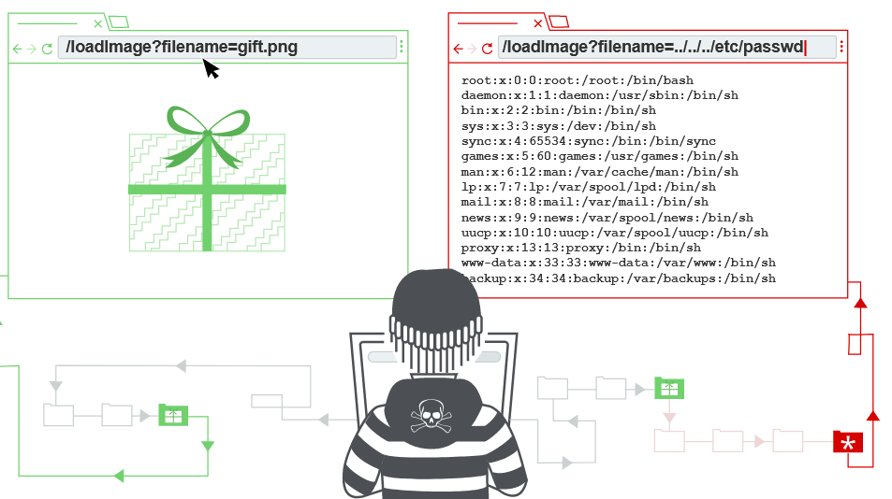

A web application can have many hidden files and directories which are not meant for the general public to access, they often contain sensitive information about the web application. In this CTF you will be required to find a hidden file as well.

# **Scenario**



You are required to find a document named acquisitions which is hidden in the About Us section of Owasp Juice Shop Web Application, Link to the web application: [**juice-shop.herokuapp.com/#/search**](http://juice-shop.herokuapp.com/#/search)

# **Process**

Step 1: Go to the owasp juice shop website: <https://juice-shop.herokuapp.com/#/search>

Step 2: Click on the **3-line button** on the top left of the corner.

Step 3: Click on the about us.

Step 4: Now change the URL to FTP only(remove all after FTP) , you will see the directories there,

Step 5: Click on the acquisitions.md button.

# **Question**

Flag 1 : Is the document confidential?

Answer : Yes

Flag Captured

Flag 2 : What does the first line of the document say

Answer : #Planned Acquisitions

Flag Captured

# **Hint**

